**Week13 Assignment Due November 28 (22 point plus 2 EC points)**

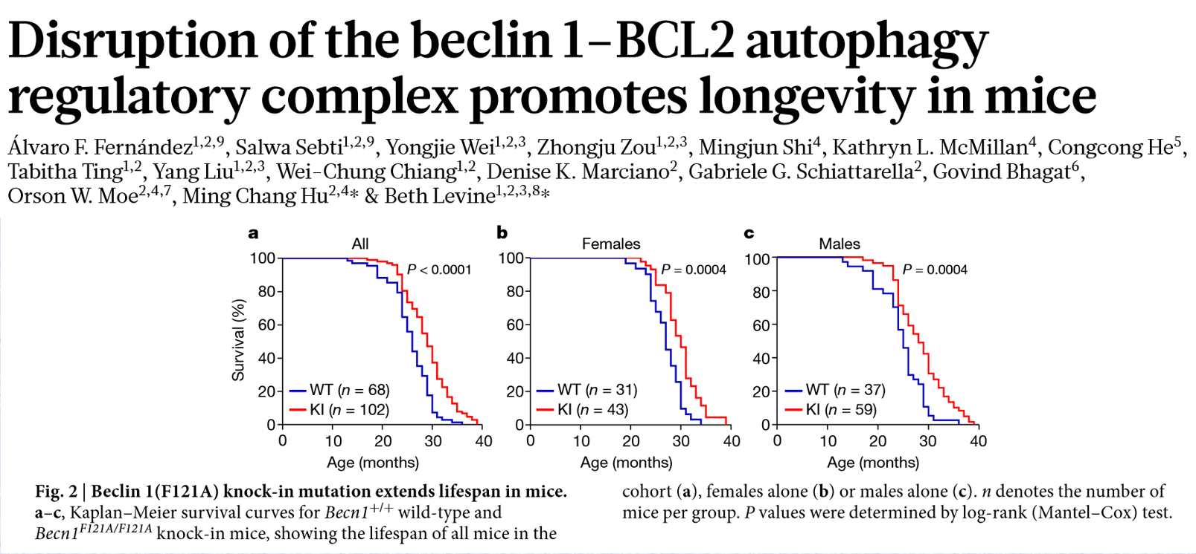

In class we looked at the data for All. For this assignment we will look at the data for females and males.

Q1. Using data from “Week13Assignment Fig2bc survival.xlsx” create a Kaplan Meier plot with all 4 groups on the same graph. Include a line at median survival and be certain we can tell the difference between the 4 groups on the graph. Limit the Y-axis to 0 to 100 and the X-axis to 0 to 40 months. (2 pts)

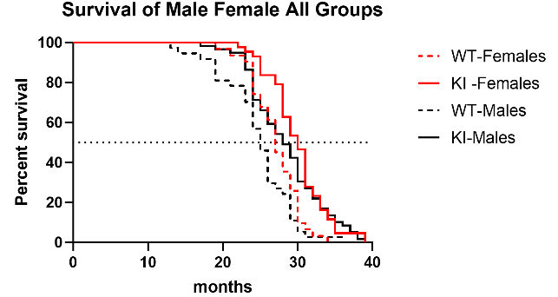

Q2. What is the difference in median survival times between KI-Female and WT-Female? KI-Male and WT-Male? (2 pts)

3 months for both

Q3. What is the log-rank p-value for differences between the curves? (1 pt)

p<0.0001

Q4. I want to know if WT and KI differ by Male and Female and if females and males differ by WT and KI. Complete the table below for my comparisons of interest. (3 pts)

Difference in median survival times Log-rank p-value

WT-Females to WT-Males _______________ ____________

KI-Females to KI-Males 2 months 0.31

Females WT to KI _______________ ____________

Males WT to KI _______________ ____________

Difference in median survival times Log-rank p-value

WT-Females to WT-Males 2 months 0.09

KI-Females to KI-Males 2 months 0.31

Females WT to KI 3 months 0.0004

Males WT to KI 3 months 0.0004

Q5. What is the threshold p-value if you want to apply a Bonferroni correction to your comparisons? (1 pt)

P = 0.05/4 = 0.0125

Q6. What comparisons are significant after accounting for multiple comparisons using Bonferroni? (1 pt)

Females WT to KI

Males WT to KI

Q7. From you analysis, do you conclude that there are differences in survival between males and females? (1 pt)

No



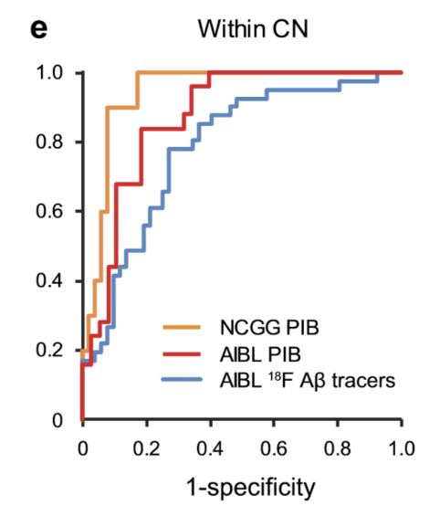

Extended Data Figure 3 | Adjusted ROC analyses corresponding to Fig. 2. e, Adjusted (age, gender, APOE4) ROC curves of the composite biomarker within cognitively normal (e) groups.

Q8. Using the data in the excel file “Week13Assignment FigEx3e ROC.xlsx, fill out the table below. The ROC curve analysis is trying to determine if the various markers can distinguish Abeta Positive (cases) from Abeta Negative (controls). (3 pts)

AUC 95% CI p-value

NCGG PiB _________ ________ ________

AIBL PiB _________ 0.79-0.96 ________

AIBL F Ab tracers 0.59 ________ 0.14

AUC 95% CI p-value

NCGG PiB 0.94 0.89-0.999 <0.0001

AIBL PiB 0.87 0.79-0.96 <0.0001

AIBL F Ab tracers 0.59 0.47-0.715 0.14

Q9. Which is the best “test” at determining Abeta positivity? Why? (1 pt)

NCGG PiB, it has the highest AUC

Q10. Which curves are different from each other? Using the Bonferroni method, what is the new threshold p-value (to 3 decimal points)? (1 pt)

3 comparisons = 0.05/3 = 0.017

Q11. Complete the table below (4 pts)

AUC difference z-score p-value

NCGG PiB to AIBL PiB ____________ ________ ________

NCGG PiB to AIBL F Ab tracers ____________ ________ <0.0001

AIBL PiB to AIBL F Ab tracers ____________ ________ ________

NCGG PiB - AIBL PiB 0.07 (or -0.07) 1.33 0.18

NCGG PiB - AIBL F Ab tracers 0.35 (or -0.35) 5.18 <0.0001

AIBL PiB - AIBL F Ab tracers 0.28 (or -0.28) 3.72 0.0002

Q12. Which of the comparisons above are significant after adjustment for multiple comparisons? (1 pt)

NCGG PiB - AIBL F Ab tracers

AIBL PiB - AIBL F Ab tracers

Q13. Using the AIBL F Ab tracers data, what is the best cut-off value using the Youden index? (1 pt)

0.3187

EC1. Re-create the graph from the paper putting all curves on one graph. Copy the graph below (2 EC pts)